Date: April 8, 2009
Grade:

Physics 205L
Charge-to-Mass Ratio of an Electron

Name: Ali Alawieh Section number: 5

Partner’s Name: Riwa Sabbagh Instructor: Lamis Zaidouny

A- DATA:
Number of turns in a coil: 65 Turns
D | 65.7 | 65.6 | 66.0 | 65.5 | 65.6
d | 34.5 | 34.2 | 34.3 | 34.6 | 34.8
I₁ (A) | 0.442 | 0.449 | 0.441 | 0.446 | 0.443

Average diameter of the Helmholtz coils: 65.7 ± 0.1 (cm)
Average diameter calculation and its error:

Average separation of the coils: 34.5 ± 0.1 (cm)
Average seperation calculation and its error:

Average value of I₁ = 0.444 ± 0.001 (A)
Average I₁ calculation and its error:

Accelerating voltage: 23 ± 0.5 (V)
[ error = lowest digit/2 when using an analog device]

Plot 1/R vs. B and calculate, using linear regression, the slope α of the line.
Determine from the slope the value of e/m with its associated error. (Hint: it is best if you use EXCEL, or some other similar program, to fill your table)
$$I=I_{2}-I_{1} at each value in the above table$$

Using the following formulas, we derive the ratio e/m in function of V, R and B:
Fm = evB
Fm = evB=mv2/R
½ mv2=eV
$$\frac{e}{m}=\frac{2V}{B^{2}R^{2}}, we manipulate the formula and get: \\ \frac{1}{R^{2}}=\frac{e.B^{2}}{2V.m}, so \frac{1}{R}=\sqrt{\frac{e}{2V.m}} .B, where: \\ y=\frac{1}{R}, x=B, a=\sqrt{\frac{e}{2V.m}}$$
For B:
$$B=\frac{N.μ_{0}.I.R^{2}}{{(R^{2}+{(\frac{d}{2})}^{2})}^{\frac{2}{3}}}=\frac{65×4π×{10}^{-7}×{\left(\frac{65.7}{2}\right)}^{2}}{{\left({\left(\frac{65.7}{2}\right)}^{2}+{\left(\frac{34.5}{2}\right)}^{2}\right)}^{\frac{2}{3} }}I=1.7256×{10}^{-4}×I$$
This gives: $a=\left(56.3±2.7\right)×10^{3} T^{-1}m^{-1}$

$$a=\sqrt{\frac{e}{2V.m}}, so\frac{e}{m}=a^{2}.2V={\left(56.3×10^{3}\right)}^{2}×2×23=1.46×{10}^{11}CKg^{-1}$$
The error on this ratio is calculated by propagation of error:
So this gives:
$$\frac{e}{m}=\left(1.46±0.14\right)×10^{11}C.Kg^{-1}$$

Repeat your measurement with a different accelerating potential: 21 ± 0.5 (V)
$$I=I_{2}-I_{1} at each value in the above table$$

$$\frac{e}{m}=\frac{2V}{B^{2}R^{2}}, we manipulate the formula and get: \\ \frac{1}{R^{2}}=\frac{e.B^{2}}{2V.m}, so \frac{1}{R}=\sqrt{\frac{e}{2V.m}} .B, where: \\ y=\frac{1}{R}, x=B, a=\sqrt{\frac{e}{2V.m}}$$
For B:
$$B=\frac{N.μ_{0}.I.R^{2}}{{(R^{2}+{(\frac{d}{2})}^{2})}^{\frac{2}{3}}}=\frac{65×4π×{10}^{-7}×{\left(\frac{65.7}{2}\right)}^{2}}{{\left({\left(\frac{65.7}{2}\right)}^{2}+{\left(\frac{34.5}{2}\right)}^{2}\right)}^{\frac{2}{3} }}I=1.7256×{10}^{-4}×I$$
This gives: $a=\left(64.8±2.0\right)×10^{3} T^{-1}m^{-1}$

$$a=\sqrt{\frac{e}{2V.m}}, so\frac{e}{m}=a^{2}.2V={\left(64.8×10^{3}\right)}^{2}×2×21=1.76×{10}^{11}CKg^{-1}$$
The error on this ratio is calculated by propagation of error:
So this gives:
$$\frac{e}{m}=\left(1.76±0.12\right)×10^{11}C.Kg^{-1}$$

Combine your two measurements and Compare your final value of e/m to the literature value. Comment.
The final value of the ration e/m is:
$$\frac{e}{m}=\frac{{\left(e/m\right)}_{1}+{\left(e/m\right)}_{2}}{2}=\frac{1.46+1.76}{2}×10^{11}=1.61×10^{11}C/Kg$$
For its error we use the propagation of error on the preceding formula since we have no enough values to calculate the standard deviation and the rms error:

So, $\frac{e}{m}\left(caculated\right)=\left(1.61±0.09\right)×10^{11}C/Kg$
If we look at the theoretical value of this ration:
$$\frac{e}{m}=$$
Consequently we find that this value lies within the range
$[(1.61-2×0.09)×10^{11}C/Kg,(1.61+2×0.09)×10^{11}C/Kg]$ That is :
$$[1.43×10^{11}C/Kg,1.79×10^{11}C/Kg]$$
So the real value is within an acceptable range of error that is 2α which mean that our measure is to a certain extent accurate.

In your determination of e/m, the errors on d, I₁ and D were not taken into consideration. How would these errors contribute to your final results?

During the calculation of the slope and the values of B and I, we neglected the errors on their components that include R, d and I₁ where $I=I_{2}-I_{1}, and$ This ignorance of the errors on D, d and I₁ which for sure affects the final result in terms of errors, where their errors should add up to the final result and the final error will be higher than the one obtained, so the error would be more and the precision less.

Looking down at the coils, their magnetic field is (out of) o r ( into) the coils. Check one.

Since F=IlBsina, the direction of F, I and B is governed by the right hand rule.
In our case,
I is downward toward the lower part of coils against electron flow.
Electrons are deflected toward the right so the force is toward the left since they are negatively charged.
So by right hand rule:
Therefore, the magnetic field is directed into the coils.

Use the value of I₁ to calculate the Earth’s magnetic field. Compare it to the literature value that may be obtained from the Internet or physics handbooks. What is the direction of the Earth’s magnetic field; into the floor or out of the floor?

We got from our measurements that : I₁ = 0.444 ± 0.001 (A)
And at this point we have no deflection what means that B_{earth}=B_{coils}
Therefore, B_{earth}=B_{coils}
We calculate the error on this value using propagation of error ( see next page), and we get:
$$B_{earth \left(calculated\right)}=76.6±0.6 μT$$$The actual value is about:50μT$ which doesn’t lie in our range [B-2α_{B},B+2α_{B}] what poses a high possibility of systematic and random errors that could be due the inaccurate viewing of the undeviated beam, the measurement of current, errors in instruments, in the number of coil turns , etc ….

Calculation of error on B: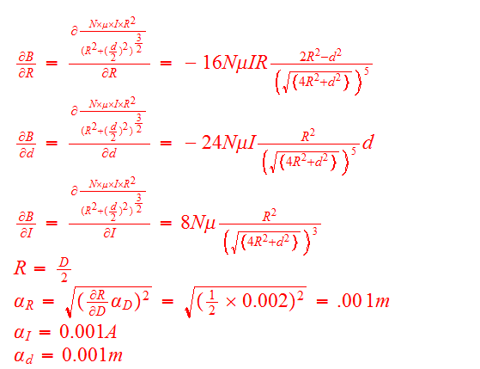
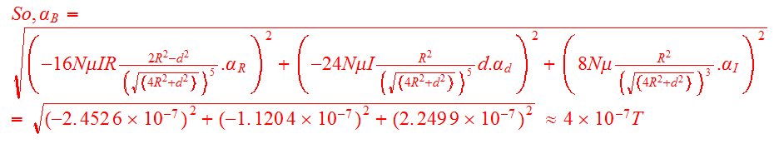
Concerning the direction of the earth magnetic field, we adjusted it so that the magnetic fields of coil and earth are on the same axis in a way that the magnetic field of the coils cancels the effect of earth magnetic field that’s why the earth magnetic field is opposite to that of coils in direction; that is, it’s out of the flour.
Why is it imperative to keep the tilt angle and the direction of the coils fixed during the experiment?

To add accuracy to our measurements we had to subtract the effect of earth magnetic field from each measured we take by subtracting the value of I1. This method recommends that both the magnetic field of coils and that of the earth to be on the same axis so that we can easily subtract them and the deflection will be the only one caused by coils.
So, if we titl the angle and direction of coil then according to our formula : F=evBsinα, so the value of the angle must be considered here as well as in the subtraction of the value of earth magnetic field since we will end up with an angle difference in direction what recommends the use of vector calculus.
Therefore, changing the angle during the experiment will cause the changing values of B and F and will end up in much more effort and less accuracy.

